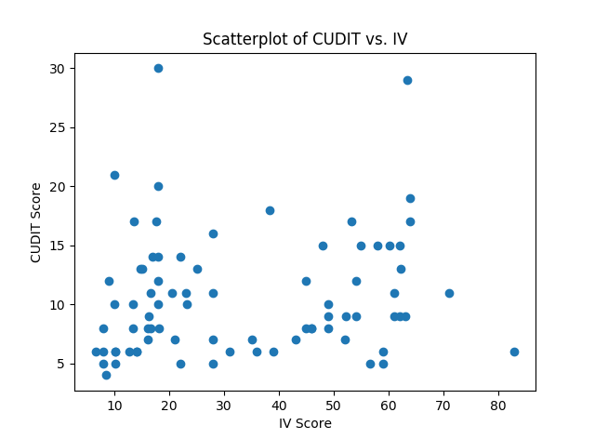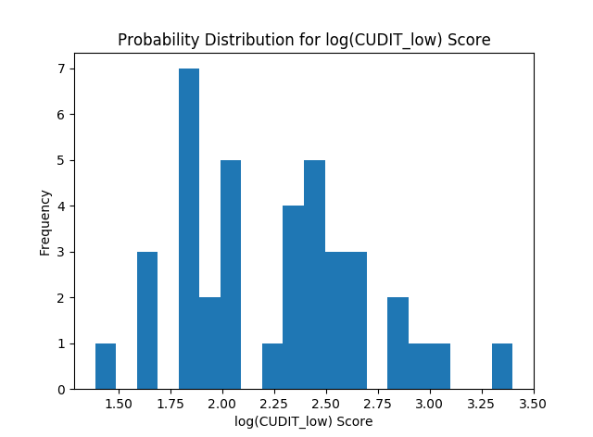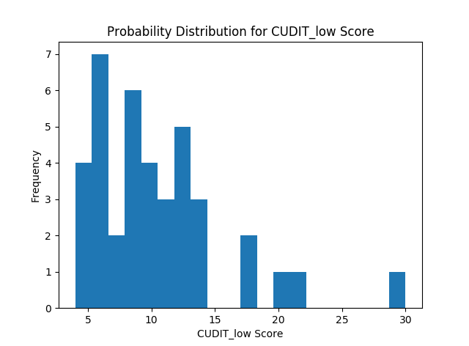

Figure 1. Scatterplots and histograms were used to observe the trends of the variables. The shapes of the distribution direction for further analysis, including necessary transformations and appropriate statistical testing methods.

|  |  |  |  |  |  |
| --- | --- | --- | --- | --- | --- |
| Correlation Coefficient | CUDIT | | IDAS | | CEQ |
| IV | $$0.1374$$ | | $$-0.4201$$ | | $$-0.02352$$ |
|  | | Mean | | Variance | |
| CUDIT_low | | 10.4359 | | 27.1690 | |
| CUDIT_high | | 10.7500 | | 24.3875 | |
| log(CUDIT_low) | | 2.2394 | | 0.2028 | |
| log(CUDIT_high) | | 2.2821 | | 0.1791 | |
| CEQ_low | | 50.2564 | | 71.7291 | |
| CEQ_high | | 48.4750 | | 109.5494 | |
| Transformed CEQ_low | | 3.8912 e+8 | | 3.3996 e+16 | |
| Transformed CEQ_high | | 3.6210 e+8 | | 5.2151 e+16 | |
| IDAS_low | | 152.0769 | | 1510.9941 | |
| IDAS_high | | 124.4500 | | 904.2975 | |

Table 1. Pearson’s correlation coefficient, as well as the means and variances were calculated in order to confirm trends from observations, as well as to provide further direction for selecting an appropriate testing method

|  |  |  |  |  |
| --- | --- | --- | --- | --- |
|  |  | CUDIT | IDAS | CEQ |
| t-test |  | 0.3347 | 0.0004263 | 0.2845 |
| Mann-Whitney U |  | 0.3200 | 0.0014581 | 0.2943 |
| Randomization |  | 0.4025 | 0.0004 | 0.2078 |

Table 2. p-Values indicate that the null hypothesis cannot be rejected for CUDIT and CEQ, while for IDAS, it supports the alternative hypothesis. Despite the varying results of the p-values obtained from the three methods, there doesn’t appear to be an egregious gap between the numbers, which indicates no blatant error in the choice of tests.

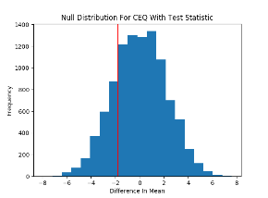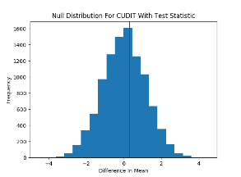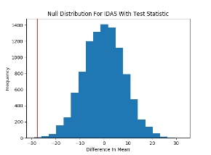

Figure 3. A visual representation of the null distributions generated by the randomization method. The red vertical lines indicate the original test statistics for each variables. Their positions graphically represent the p-values, with only IDAS deviating significantly from the null distribution.